***THEJAZZICIANS***

***Present the***

**4th Annual Festival of *Jazz***



* ***Join us for a fun-filled day of entertainment for the whole family.***
* *Festival attractions include games, rides, food, crafts, and live music from the talented artists of The Brass Beat, Dave and the Hornets, and The Nance Lance Band*.
* *Hope to see you there*

SAILING CLUB

**Monthly Meeting**

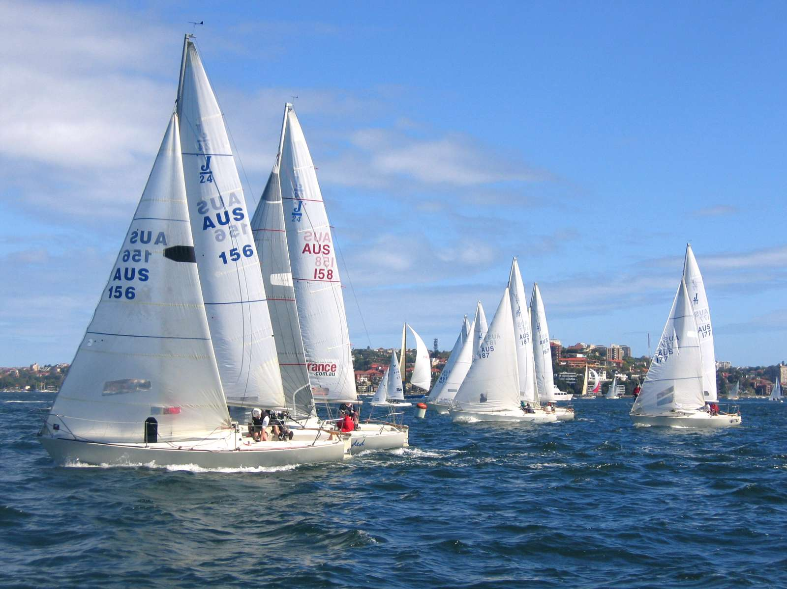

**Plan to attend the meeting of the Sailing Club on May 1, 2012, in the auditorium of Queensborough Community College.**

**Ranger Robin Hood will lecture on:**

* **Harbor Patrol rules and regulations**
* **Basic sailing techniques**

**Please call Little John, (718) 631-6207, to make your reservation.**

**Reservations Required**

**See You There!**